TRANSFORMER
A Transformer is a deep learning architecture introduced in the 2017 paper "Attention Is All You Need" that revolutionized Natural Language Processing (NLP) and later became the foundation of modern Large Language Models (LLMs) such as GPT, BERT, Llama, Claude, and Gemini. Unlike earlier sequence models such as Recurrent Neural Networks (RNNs) and Long Short-Term Memory networks (LSTMs), which process words one at a time, a Transformer processes an entire sequence simultaneously. This parallel processing allows it to train much faster and capture long-range dependencies between words more effectively. The core idea behind the Transformer is the attention mechanism, which enables every word in a sentence to dynamically determine which other words are important for understanding its meaning. For example, in the sentence "The animal didn't cross the street because it was tired," the model learns that the word "it" refers to "animal" by assigning higher attention to that word. This ability to selectively focus on relevant information is what makes Transformers extraordinarily powerful.
WORKING:
The Transformer workflow begins when input text is broken into smaller units called tokens. Each token is converted into a numerical vector through an embedding layer, creating a mathematical representation of the text. Since Transformers process all tokens simultaneously, they need a way to understand word order. This is achieved using Positional Encoding, which injects information about each token's position in the sequence. The resulting vectors are then passed through a series of Transformer layers. Inside each layer, the model generates three vectors for every token: a Query (Q) vector that asks what information the token is looking for, a Key (K) vector that describes what information the token contains, and a Value (V) vector that stores the actual information. Attention scores are computed by comparing Queries with Keys, determining how strongly each token should attend to every other token. These scores are normalized using the Softmax function and then used to weight the Value vectors, producing a new context-aware representation of each token.
To increase learning capacity, Transformers use Multi-Head Attention, where several attention mechanisms operate in parallel. Each head learns different linguistic relationships such as grammar, semantic meaning, entity references, or contextual dependencies. The outputs from all attention heads are combined and passed through a Feed-Forward Neural Network (FFN) that performs additional transformations. Throughout the architecture, Residual Connections and Layer Normalization are employed to stabilize training and prevent information loss as data passes through many layers. In the original Transformer architecture, the Encoder stack creates rich contextual representations of the input sequence, while the Decoder stack generates output tokens one at a time using both self-attention and encoder-decoder attention. Modern generative models like GPT use only the decoder portion, whereas models such as BERT primarily use encoder layers.
One of the most important reasons Transformers outperform previous architectures is that they can model relationships between words regardless of their distance in a sentence. Traditional RNNs struggle to remember information from earlier parts of a sequence because information must travel through many intermediate steps. Transformers eliminate this bottleneck by allowing direct interaction between all tokens through self-attention. This capability scales effectively to billions of parameters and massive datasets, enabling modern AI systems to understand context, answer questions, translate languages, summarize documents, write code, generate images, and perform complex reasoning tasks. As a result, the Transformer architecture has become the fundamental building block behind nearly every state-of-the-art AI model developed today.

Transformer Architecture Workflow Diagram:

┌─────────────────┐
│ Input Text │
│ "I love AI" │
└────────┬────────┘
│
▼
┌─────────────────┐
│ Tokenization │
│ [I, love, AI] │
└────────┬────────┘
│
▼
┌─────────────────┐
│ Embedding Layer │
│ Convert tokens │
│ to vectors │
└────────┬────────┘
│
▼
┌─────────────────┐
│ Positional │
│ Encoding │
│ Add word order │
└────────┬────────┘
│
▼
┌─────────────────────────────────────────┐
│ TRANSFORMER BLOCK │
│ │
│ ┌──────────────────────────────────┐ │
│ │ Multi-Head Attention │ │
│ │ (Learn relationships between │ │
│ │ all words in parallel) │ │
│ └──────────────┬───────────────────┘ │
│ │ │
│ Residual Connection │
│ │ │
│ ▼ │
│ Layer Normalization │
│ │ │
│ ▼ │
│ ┌──────────────────────────────────┐ │
│ │ Feed Forward Neural Network │ │
│ │ (Non-linear transformations) │ │
│ └──────────────┬───────────────────┘ │
│ │ │
│ Residual Connection │
│ │ │
│ ▼ │
│ Layer Normalization │
└─────────────────┬───────────────────────┘
│
Repeated N Times
│
▼
┌──────────────────┐
│ Context-Aware │
│ Representations │
└────────┬─────────┘
│
▼
┌──────────────────┐
│ Linear Layer │
└────────┬─────────┘
│
▼
┌──────────────────┐
│ Softmax │
│ Probabilities │
└────────┬─────────┘
│
▼
┌──────────────────┐
│ Output Token │

Multi-Head Attention
Instead of learning a single relationship, the Transformer learns many relationships simultaneously.

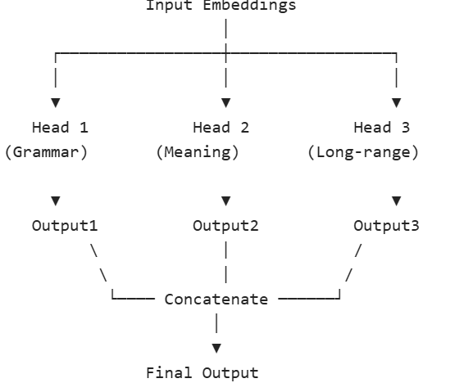

Encoder Layer Diagram
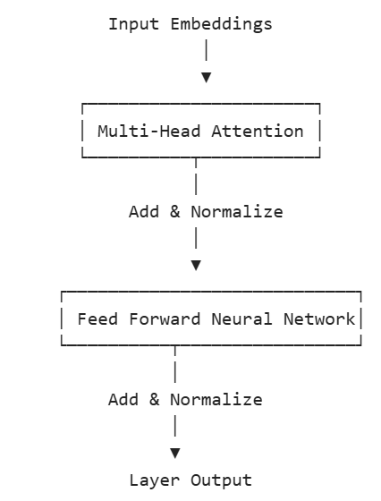
Decoder Layer Diagram (GPT Uses a Variant of This)
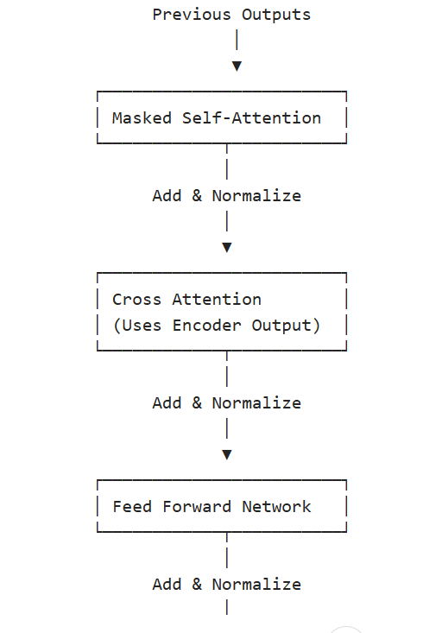
tokens
Pretraining vs Fine-Tuning in Transformers
Modern Transformer-based models such as GPT, BERT, Llama, and T5 are typically developed in two major phases: Pretraining and Fine-Tuning. These phases allow a model to first learn general knowledge about language and then specialize in specific tasks.

1. Pretraining
Pretraining is the initial learning phase where a Transformer is trained on massive amounts of unlabeled data, often consisting of books, websites, articles, research papers, and code repositories. During this stage, the model learns the fundamental structure of language, grammar, reasoning patterns, facts, semantic relationships, and contextual understanding.
The objective is not to teach the model a specific task but rather to help it develop a broad understanding of how language works. For example, GPT models are typically trained using a next-token prediction objective, where the model predicts the next word in a sequence:
Input: "Artificial Intelligence is"
Target: "transforming"
By repeating this prediction billions of times across huge datasets, the model gradually learns:
- Vocabulary and grammar
- Facts about the world
- Logical relationships
- Programming languages
- Writing styles
- Context understanding
Characteristics of Pretraining
- Uses extremely large datasets
- Requires enormous computational resources
- Learns general-purpose knowledge
- Usually performed only once by model developers
- Produces a foundation model

Pretraining Workflow:

Massive Text Corpus
│
▼
Tokenization
│
▼
Transformer Model
│
▼
Predict Missing / Next Tokens
│
▼
Calculate Error
│
▼
Update Weights
│
▼
Repeat Billions of Times
│
▼
Foundation Model

2. Fine-Tuning
Once pretraining is complete, the model possesses broad language knowledge but may not excel at a particular task. Fine-tuning is the process of further training the pretrained model on a smaller, task-specific dataset.
Instead of learning language from scratch, the model adapts its existing knowledge to solve a particular problem.
Examples:
Task | Fine-Tuning Dataset
Sentiment Analysis | Positive/Negative Reviews
Medical Diagnosis | Medical Records
Chatbot | Human Conversations
Code Generation | Source Code Repositories
Legal AI | Legal Documents
For example, a pretrained model may know the meaning of medical terms. Fine-tuning on healthcare data teaches it how doctors communicate and how to answer medical questions more accurately.

Fine-Tuning Workflow:
Plain Text
Pretrained Transformer
│
▼
Task-Specific Dataset
│
▼
Additional Training
│
▼
Weight Adjustments
│
▼
Specialized Model
Visual Comparison
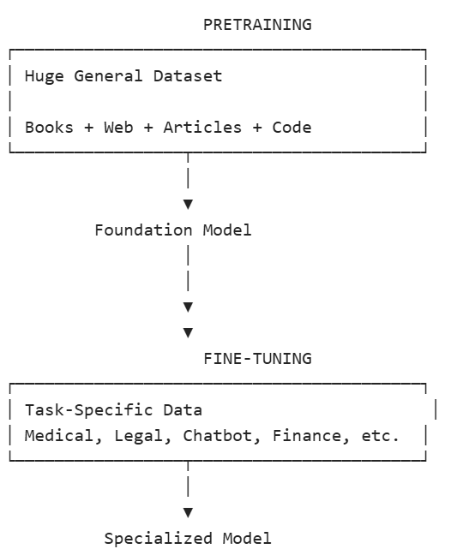

Tokenization
Tokenization is the first step in a Transformer model's pipeline. It is the process of breaking raw text into smaller units called tokens, which can be words, subwords, characters, or even punctuation marks. Since neural networks cannot directly process text, tokenization converts human language into discrete units that the model can understand.
Common Tokenization Methods
1. Word Tokenization
Plain Text
I love Generative AI
↓
["I", "love", "Generative", "AI"]
Simple but struggles with unseen words.
2. Character Tokenization
Plain Text
AI
↓
["A", "I"]
Very flexible but creates long sequences.
3. Subword Tokenization (Most Common)
Plain Text
unhappiness
↓
["un", "happi", "ness"]
Used in GPT, BERT, Llama, and most modern LLMs because it balances vocabulary size and flexibility.
Token IDs
After tokenization, each token is mapped to a numerical ID using a vocabulary lookup table.
Plain Text
["I", "love", "AI"]
↓
[105, 432, 892]
These token IDs become the input to the embedding layer.
Embeddings
Once text has been converted into token IDs, the Transformer must transform these integers into meaningful numerical representations. This is done through Embeddings.
An Embedding is a dense vector representation of a token in a high-dimensional space. Instead of representing words as simple numbers, embeddings capture semantic meaning and relationships between words.
"King" → [0.12, -0.45, 0.78, ...]
"Queen" → [0.15, -0.42, 0.81, ...]
"Dog" → [-0.67, 0.12, -0.23, ...]
Because "King" and "Queen" are semantically related, their vectors are located close together in the embedding space.
Why Embeddings are Needed
Token IDs have no meaning by themselves:
Plain Text
King → 2456
Queen → 3921
Dog → 789
The model cannot infer relationships from these numbers.
Embeddings convert them into vectors that encode:
- Meaning
- Context
- Similarity
- Semantic relationships

Embedding Workflow
Plain Text
Raw Text
↓
Tokenization
↓
Token IDs
↓
Embedding Lookup
↓
Dense Vector Representations
Example:
Plain Text
Sentence:
"I love AI"

Token IDs:
[101, 205, 301]

Embedding Matrix Lookup:
[101] → [0.2, 0.1, -0.4]
[205] → [-0.7, 0.8, 0.2]
[301] → [0.5, -0.1, 0.9]
Result:
Plain Text
[
[0.2, 0.1, -0.4],
[-0.7, 0.8, 0.2],
[0.5, -0.1, 0.9]
]
These vectors are what the Transformer actually processes.
Embedding Matrix
Internally, a Transformer maintains a large trainable matrix called the Embedding Matrix.
Plain Text
Vocabulary Size × Embedding Dimension
Example:
Plain Text
50,000 × 768
where:
- 50,000 = number of tokens in vocabulary
- 768 = vector size of each token
Plain Text
Embedding Matrix

Token 1 → [0.1, 0.4, 0.9, ...]
Token 2 → [0.5, 0.3, 0.2, ...]
Token 3 → [0.8, 0.7, 0.1, ...]
...
Token N → [...]
During training, these embeddings are continuously updated to better capture word meanings.
Positional Encoding After Embedding
One limitation of embeddings is that they contain meaning but not order.
For example:
Plain Text
Dog bites man
and
Plain Text
Man bites dog
would initially contain the same token embeddings arranged differently.
To help the Transformer understand sequence order, Positional Encodings are added to embeddings.
Plain Text
Final Input =
Token Embedding +
Positional Encoding
Plain Text
Token Embedding
+
Positional Encoding
↓
Position-Aware Embedding
Complete Flow
Plain Text
Text Input
│
▼
Tokenization
│
▼
Tokens
│
▼
Token IDs
│
▼
Embedding Layer
│
▼
Dense Word Vectors
│
▼
Positional Encoding
│
▼
Transformer Layers
│
▼
Attention Computation

